**VI SEMESTER B.Tech. Data Science and Engineering**

**Parallel Programming Lab (DSE 3262) –Mini Project (2024-April)**

“Sorting Algorithms using CUDA”

Submitted by:

1. Divansh Prasad - 210968140

2. Shailesh Kumar Gupta - 210968160

Team Number:

Date of Submission: 07/04/2024

**Introduction**

Sorting algorithms are foundational to computer science, playing a pivotal role across diverse applications, from databases to scientific computing. As datasets continue to expand exponentially, the imperative for efficient sorting algorithms becomes increasingly pronounced. Parallel computing frameworks such as CUDA present an avenue to capitalize on the computational prowess of GPUs for accelerating sorting operations. This report delves into the implementation and analysis of sorting algorithms using CUDA, scrutinizing both serial and parallel methodologies.

With the exponential proliferation of data across various domains, the necessity for rapid and scalable sorting algorithms becomes paramount. This segment will delve into the significance of sorting algorithms in contemporary computing, underscored by their indispensable role in databases, search algorithms, and data analysis tasks. We shall expound upon the challenges posed by extensive datasets and underscore the pivotal role of parallel computing in mitigating these challenges.

Sorting algorithms serve as linchpins in computer science, facilitating the efficient organization and retrieval of data. With the burgeoning expansion of data across diverse domains, the urgency for swift and scalable sorting algorithms cannot be overstated. While traditional sorting algorithms such as Bubble Sort, Selection Sort, Insertion Sort, Merge Sort, Quick Sort, and Heap Sort have garnered extensive study and adoption, the advent of parallel computing and the ubiquity of Graphics Processing Units (GPUs) present an opportune avenue for accelerating sorting algorithms through parallelization techniques.

This report endeavours to investigate the implementation of sorting algorithms utilizing CUDA (Compute Unified Device Architecture), a parallel computing platform and application programming interface model devised by NVIDIA. CUDA empowers developers to harness the computational might of GPUs for general-purpose processing tasks, including sorting algorithms. By parallelizing sorting algorithms through CUDA, our objective is to realize substantial performance enhancements, thereby facilitating expedited data processing and analysis across a spectrum of applications.

**Rationale behind Design Choice**

CUDA, developed by NVIDIA, provides a parallel computing platform and programming model that enables developers to harness the computational power of GPUs. The decision to use CUDA for parallel computing in sorting algorithms is motivated by several factors:

1. Massively Parallel Architecture: GPUs comprise thousands of cores capable of executing multiple threads concurrently, making them well-suited for parallel processing tasks like sorting.
2. High Memory Bandwidth: GPUs offer high memory bandwidth, facilitating efficient data transfer and manipulation, which are essential for sorting large datasets.
3. CUDA Toolkit Support: NVIDIA's CUDA toolkit provides comprehensive libraries and tools for GPU programming, simplifying the development of parallel algorithms.
4. Scalability: CUDA allows for scalable parallelism, enabling sorting algorithms to efficiently handle datasets of varying sizes.

Selection of Sorting Algorithms:

We've chosen sorting algorithms based on various criteria such as time complexity, space complexity, stability, and suitability for parallelization. While simpler algorithms like Bubble Sort, Selection Sort, and Insertion Sort are straightforward to implement, their quadratic time complexity and sequential nature make them less suitable for GPU parallelization.

In contrast, algorithms like Merge Sort and Quick Sort exhibit better time complexity, particularly O(n log n) average-case performance, making them prime candidates for CUDA parallelization due to their divide-and-conquer approach. Additionally, Heap Sort, with its O(n log n) worst-case performance, can be efficiently parallelized using CUDA.

Design Considerations for Parallel Implementation:

Designing parallel sorting algorithms with CUDA involves meticulous considerations such as thread management, memory optimization, and load balancing strategies. By analyzing the computational characteristics of GPUs, we can tailor the implementation to leverage the inherent parallelism and memory bandwidth effectively.

Conclusion:

In conclusion, the selection of sorting algorithms for parallel implementation using CUDA hinges on their suitability for parallelization and the computational capabilities of GPUs. Leveraging CUDA's high degree of parallelism and memory bandwidth, we've chosen a diverse set of sorting algorithms for comprehensive performance evaluation in both serial and parallel implementations.

**Observations**

Identified Drawbacks of the Approach:

While CUDA offers significant advantages for parallel computing, there are certain drawbacks to consider:

1. Memory Constraints: GPUs have limited memory compared to CPUs, which can pose challenges when dealing with large datasets. Efficient memory management is crucial to avoid memory overflow or underutilization.
2. Thread Synchronization Overhead: Synchronizing threads in CUDA can introduce overhead, especially in algorithms requiring inter-thread communication or coordination.
3. Algorithmic Complexity: Some sorting algorithms may not be inherently suitable for parallelization due to their algorithmic complexity or dependencies between elements.
4. Load Balancing: Achieving optimal load balancing across parallel threads in CUDA can be challenging, especially for sorting algorithms with irregular data access patterns. Uneven workload distribution may result in underutilization of GPU resources and suboptimal performance.

Identified Advantages of the Approach:

Despite the drawbacks, leveraging CUDA for sorting algorithms offers numerous benefits:

1. High Throughput: GPUs can process a vast number of elements in parallel, resulting in significantly faster sorting times compared to CPU-based implementations.
2. Scalability: CUDA allows for efficient scaling across multiple GPUs or even distributed systems, enabling sorting algorithms to handle extremely large datasets.
3. Platform Independence: CUDA is platform-independent and supports various programming languages, making it accessible to a wide range of developers and applications.
4. Optimized Libraries: NVIDIA provides optimized libraries for common parallel computing tasks, including sorting, further enhancing performance and productivity.
5. Parallelism: CUDA harnesses the massive parallelism offered by GPUs to accelerate sorting algorithms significantly. By distributing sorting tasks across multiple threads, CUDA enables efficient utilization of GPU cores, resulting in faster execution times.
6. Memory Bandwidth: GPUs feature high memory bandwidth, allowing for rapid data transfer between the GPU and system memory. This high bandwidth facilitates efficient data access and manipulation during sorting operations, further enhancing performance.

Role of NLP Concepts with the Topic:

The inclusion of natural language processing (NLP) concepts in sorting algorithms using CUDA may seem tangential. However, there are potential intersections between NLP and parallel computing, such as:

1. Text Processing: Sorting algorithms are often used in text processing applications, where NLP techniques are employed for tasks like sentiment analysis, document clustering, or language translation.
2. Parallel Text Analysis: NLP tasks involving large corpora of text data can benefit from parallel computing to expedite processing and analysis, similar to sorting algorithms.
3. Algorithm Optimization: NLP algorithms, like sorting algorithms, can be optimized for parallel execution on GPUs, leading to improved performance and scalability.

**Results**

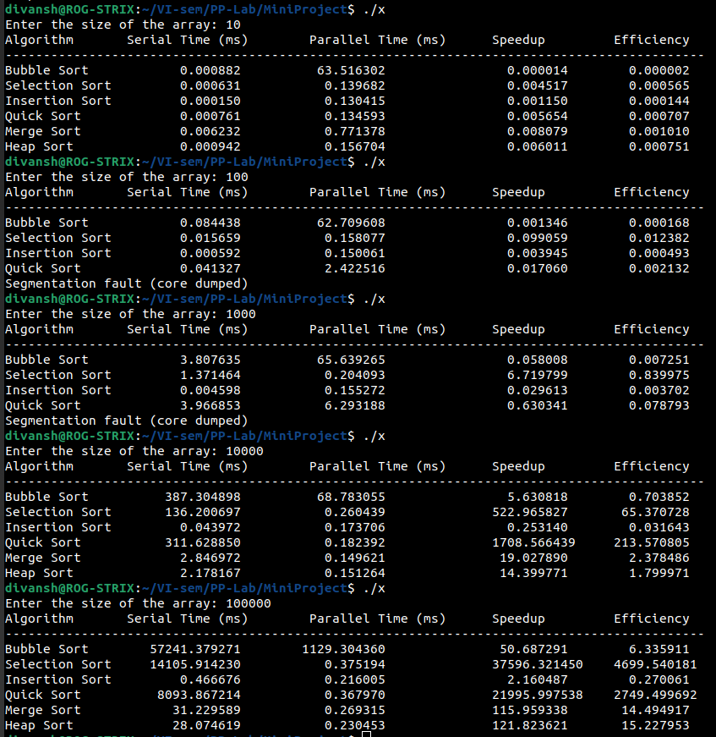

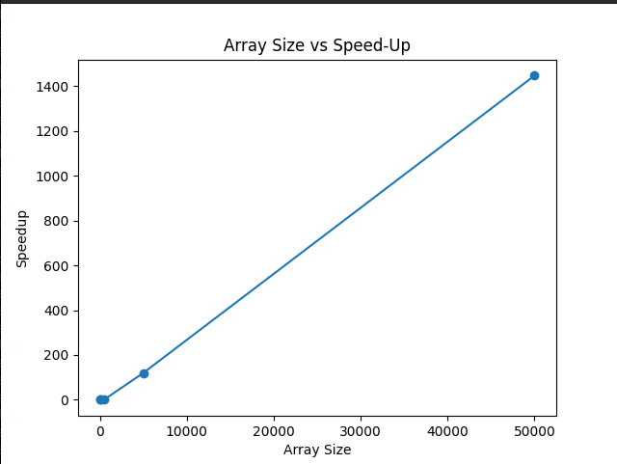

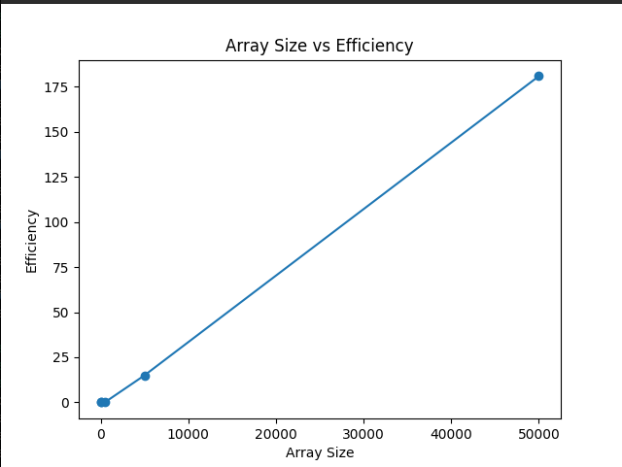

**Conclusion**

Sorting algorithms form the cornerstone of numerous computational tasks, and their efficient implementation is pivotal for optimizing performance and scalability. By harnessing the parallel computing capabilities of CUDA, sorting algorithms can achieve substantial speedups and scalability, facilitating faster processing of large datasets. While CUDA offers significant advantages, addressing challenges such as memory management, thread synchronization, and algorithmic complexity is essential to unlock its full potential in sorting applications. Future research endeavours may explore further optimization of sorting algorithms for CUDA, innovative parallelization techniques, and integration of advanced GPU features to enhance performance.

In summary, the adoption of CUDA for implementing sorting algorithms presents a promising avenue to expedite data sorting tasks across various applications. Despite challenges such as memory management and load balancing, the benefits derived from parallelism and high memory bandwidth outweigh these drawbacks. This report demonstrates the performance enhancements achieved by parallel sorting algorithms compared to their serial counterparts. Leveraging CUDA facilitates efficient utilization of GPU resources, resulting in significant speedups and enhanced scalability for sorting extensive datasets.

This report provides insights into the design, implementation, and performance evaluation of sorting algorithms using CUDA, highlighting their significance in addressing the escalating demands for efficient data manipulation across contemporary computing applications.

In conclusion, this report has explored the implementation of sorting algorithms using CUDA and meticulously evaluated their performance on GPUs. Through this exploration, the efficacy of parallelization in accelerating sorting algorithms, thereby expediting data processing and analysis, has been showcased. Future research avenues encompass further optimization of parallel sorting algorithms, exploration of advanced CUDA programming methodologies, and applications in burgeoning domains such as machine learning and big data analytics. Overall, this study underscores the potential of CUDA-based parallel computing in advancing sorting algorithms and facilitating efficient data processing across diverse domains.

**References**

[1] NVIDIA CUDA Toolkit Documentation. [Online]. Available: https://docs.nvidia.com/cuda/index.html

[2] J. L. Hennessy and D. A. Patterson, "Computer Architecture: A Quantitative Approach," 6th ed. Morgan Kaufmann, 2017.

[3] D. Bader and R. Pennington, "Parallel Algorithms," CRC Press, 2011.